P210/1
History
Paper 1
3 HOURS
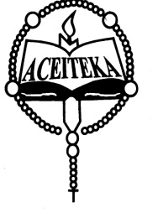
ACEITEKA JOINT MOCK EXAMINATIONS 2023
UGANDA ADVANCED CERTIFICATE OF EDUCATION
HISTORY
(Africa: National Movements and the new states)
PAPER 1
TIME: 3 HOURS

Instructions:
- Answer any four questions only
- All questions carry equal marks
- Any extra question will not be marked.

- Examine the influence of USA and USSR in the decolonization process of Africa. (25 marks)
- Assess the role of the Pan –African Movement (PAM) in the liberation of Ethiopia by 1941.
(25 marks)
- Account for the defeat of the Madagascar uprising in 1948. (25 marks)
- Assess the role of Habib Bourguiba in the attainment of independence by Tunisia in 1956.
(25 marks)
- Examine the role of Hastings Kamuzu Banda in the struggle for independence of Nyasaland.
(25 marks)
- How far has state control over Education contributed to National development in any one independent state of East Africa? (25 marks)
- “The policies of the White Settlers were primarily responsible for the outbreak of the Liberation war in Mozambique,” Discuss. (25 marks)
- Examine the impact of Foreign Aid on any one post independent African state. (25 marks)
- Discuss the causes and consequences of the 1965 coup in Congo – Kinshasa. (25 marks)
- How did the collapse of civilian rule in Libya in 1969 affect the people? (25 marks)
END

